CHAPTER-I

Fashion Haven

Introduction:

We Started fashion Haven because we wanted to see changes in the fashion industry. There are many emerging designers who do know how to market their clothing so we are here to help. Also, there are many fashionistas who wants to buy designer clothing but can't afford to purchase them. Fashion Haven is the place tat will put designers with fashion trendy buyers.  
  
 Fashion Haven is a premier online marketplace to find unique and one of a kind Designer Inspired pieces. We work directly with emerging designers around the world to bring you the best selection of high-quality, one of a kind inspired pieces the industry has to offer.  
  
 Fashion is an art form that allows individuals to express themselves through clothing and accessories. It is a constantly evolving industry that is influenced by cultural, social, and economic factors. In recent years, several types of fashion have emerged, each with its own unique char At the start of the show the host should introduce the show giving a brief run-down of the ingredients of the show. This should include information about why you are raising money. The host should introduce each model in turn and describe the clothes and give the I am a creative and passionate individual possessing excellent communication skills and the crucial ability to function well both independently and in fast-paced team environments. Having worked as a Fashion Stylist for more than three years, I am fully adept at all aspects fashion is the most general term and applies to any way of dressing, behaving, writing, or performing that is at any one time or place. the current fashion. style often implies a distinctive fashion adopted by people of taste

**PURPOSE:**

* The fashion industry helps preserve and promote cultural heritage by incorporating traditional designs.
* The reflection of latest trends in our lifestyle, like in eating, wearing, talking or interacting, is the fashion. Fashion is anything that’s change in our life.
* **Fashion is reflection of latest trends and changes**in our habits, lifestyles, food, clothes and in every walk of our life.
* Fashion is something that comes from within. It is a way of expressing ourselves and our personality.
* The way we dress, the way we style our hair, the accessories we use, all these things are a part of fashion.
* Fashion is not just about following the latest trends; it is also about being comfortable in your own skin and with what you are wearing.
* It is about expressing yourself and your personality in the way you dress. You don’t have to wear the latest designer clothes or follow the latest trends to be fashionable.
* There is no one definition of fashion; it is different for everyone. Techniques, and materials into modern clothing.

CHAPTER-2

EMPATHY MAP

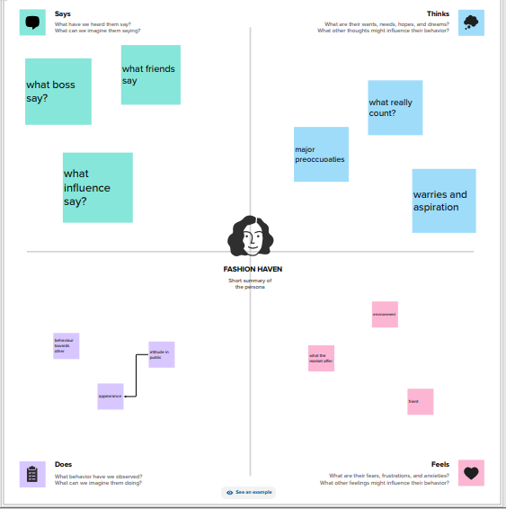

BRAINSTOMING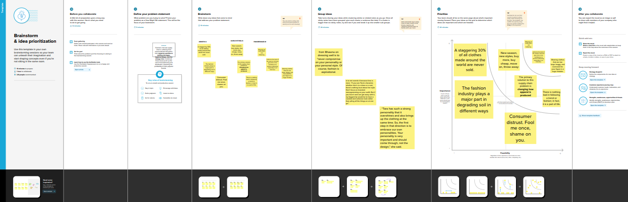

CHAPTER-3





CHAPTER-4

ADVANTAGE OF FASHION HAVEN

* Clothing can insulate against cold or hot conditions, and it can provide a hygienic barrier, keeping infectious and toxic materials away from the body
* It can protect feet from injury and discomfort or facilitate navigation in varied environments. Clothing also provides protection from ultraviolet radiation
* Fashion has the power to transform an ordinary look into a branded, modern style, helping people attract attention from those they admire
* Teenagers express themselves through their clothes and hairstyles. The clothes a teenager wears are a way of individuating themselves and demonstrating how they wish to be perceived
* Accordingly, consumers know to purchase an item they like when they see it, no matter the price because it's not likely to be available for long.
* . Additionally, fashion serves as a universal language that connects people from different cultures and regions of the world.29-Apr-2023
* wearing different designer clothes or dresses ins insert a feeling of self-confidence. And also feel confident and independent in your choice.
* The pollution introduced by the fast fashion industry results in devastating impacts to both terrestrial and aquatic environments, with harmful effects linked to **habitat degradation, proliferation of chemicals and microplastics in waterways**, and the increasing impact of climate change from anthropogenic greenhouse gas
* Clothing can **change people's perception of you and it can also change how you view yourself**
* **The clothes we wear tell stories of our culture and our heritage** – things that can't easily be shrugged on and taken off at will.

DISADVANTAGE OF FASHION HAVEN

* Fashion trends can create social pressure to conform, leading to a lack of individuality and self- expression
* Body Image Concerns: Some trends may not be inclusive of all body types, leading to body image issues and self-esteem issues. Ethical Concerns: Many fashion try
* **Plastic fibres are polluting the oceans, the wastewater, toxic dyes, and the exploitation of underpaid workers**
* Fast fashion is big business, and while the environmental costs are rising, experts say there is another way: a circular economy for textiles.
* **Fashion production makes up 10% of humanity's carbon emissions, dries up water sources, and pollutes rivers and streams**.
* **Waste occurs at every stage of the garment manufacturing process, harming wildlife, degrading land, and polluting soil and water**
* . The fast fashion industry is a significant contributor to the climate crisis, responsible for as much as 10% of global carbon dioxide
* The most important disadvantage is that **it is a major cause of stress amongst the younger generation**.
* Students often get anxiety attacks and stress-related health issues when they are not able to keep up with the trends.
* And when consumers throw away clothing in the garbage, not only does it waste money and resources, but it can take 200+ years for the materials to decompose in a landfill.
* During the decomposition process, **textiles generate greenhouse methane gas and leach toxic chemicals and dyes into the groundwater and our soil**.

CHAPTER-5

**APPLICATIONS**

A little good news amid all the gloom. Technology is paving the way to a more [sustainable future for fashion](https://www.worldfashionexchange.com/blog/what-is-sustainable-fashion-why-fashion-brands-need-to-be-more-sustainable/)! Here’s few ways to get started:

* Ensure all the factories you work with have strict policies around worker hygiene and safety.
* Use 3D design solutions to test samples for fit, design and quality before manufacturing physical pieces to minimize waste.
* Use less resource-intensive sustainable materials that are not as harmful for the environment.
* Make use of analytics and production intelligence to forecast demand and avoid overproduction.
* Increase transparency in your supply chain by using production tracking software such as PLM and [ERP](https://www.worldfashionexchange.com/apparel-erp-software.html) to establish accountability.
* Encourage customers to resell or rent clothing instead of buying and discarding after one or two uses.
* Collect data about your supply chain to identify where there’s room for improvement and efficiency.
* Implement holographic labels and watermarks. These labels on product packaging and tags can make it difficult for counterfeiters to replicate the look of authentic products.
* Trademark important words or design elements, which makes it easier to pursue legal action against those who try to copy you.
* You can further protect your brand by working with trusted manufacturers who won’t share your design with others or fudge on materials requirements and specs.

* Encourage your consumers to buy authentic items—ideally directly from you! And by “encourage,” I mean through education, incentives, and other tactics designed to get customers excited about buying your products directly.
* Use software programs that can help you detect when someone is using your images or content without permission on the Internet.

**CHAPTER-6**

**CONCLUSION**

**Fashion can be overlooked and downplayed quite often. Fashion is so much more than just throwing on a pair of pants with a shirt. Fashion and personal style means something to people. It a way of expressing who someone is or to prove themselves to others, it a woman vulnerability, style is something that is someone own and makes a person feel unique and individual.**

**For as long as time can tell fashion has played a huge role in the world and it something people will never not need. Fashion is constantly evolving and changing and with each era of life comes a new style and trends. Fashion patterns travel every which way; then a general public's esteems are built up and developing trademark to their convictions and culture.**

**Fashion is recently not a driven anticipated picture of a reinterpreted decent old incentive to satisfy some capacity or motivation alike yet rather a suggestive and invigorating idea sufficiently commendable to be depicted for society's gratefulness that makes us significantly more intuitive.**

CHAPTER-7

**FUTURE SCOPE**

**It is one of the most ambitious career options for all. A** [**Fashion Designer**](https://textilelearner.net/11-tips-to-become-a-successful-fashion-designer/) **is someone who builds up new ideas based on the latest trends and innovation that are leading the world. Designing concepts and apparel is what they essentially do. The person who dreams up creative concepts and are always up to date about what’s happening in the fashion world, may wish to choose this path.**

**As the name suggests, a Fashion Illustrator presents drawings and illustrates the ideas of a fashion designer on paper and/or on computers. To pursue career in this, one need to be really good at drawing and illustration. One will get to work closely with designers to bring their ideas and designs to reality.**

**Fashion Designers and Illustrators design, stylists put them beautifully. They manage for makeup, accessories, hair styles, and everything else to make sure the model looks awesome wearing the designs. For this, one need to have an amazing sense of style and should be skill with accessorizing to shine in this path.**

**The demand for fashion consultants are increasing nowadays. They are someone who help individuals choose their style based on their image, their personality, and looks. One should know the trends of the industry as well as basics of fashion designing to take on this route.**

**The work of fashion director is to manage fashion companies or houses and also directs** [**fashion shows**](https://textilelearner.net/fashion-show-types/)**. They need to have overall understanding of how the industry works, have amazing research and network skills to run the shows successfully. Apart from this consumer behaviour, the main skill to become fashion director is advertising tactics and marketing skills.**